3/29/2016
David Spirek
Disciple making ministries
www.disciplemakingministries.org
Committed to Christ
Ten Foundational Lessons for New Believers
A Committed Christian is…
Table of Contents
Unit 1: Committed to Christ – Lesson 1: Salvation 2
Unit 1: Committed to Christ – Lesson 2: Baptism 3
Unit 2: Committed to the Cause of Christ – Lesson 1: The Holy Spirit 5
Unit 2: Committed to the Cause of Christ – Lesson 2: Bible Study 7
Unit 2: Committed to the Cause of Christ – Lesson 3: Prayer 8
Unit 2: Committed to the Cause of Christ - Lesson 4: Sharing Your Faith 9
Unit 3: Committed to the Body of Christ – Lesson 1: Participation in Church 12
Unit 3: Committed to the Body of Christ – Lesson 2: Unity 14
Unit 3: Committed to the Body of Christ – Lesson 3: Giving 16
Unit 3: Committed to the Body of Christ – Lesson 4: Serving with Spiritual Gifts 18

Unit 1: Committed to Christ – Lesson 1: Salvation
Question:
What does it mean to be saved?
The Problem:
God is perfect. He is absolutely without fault. The Bible says He is holy. Due to His perfect nature – He can have no association with sin.
Man is sinful. All people have chosen to rebel against God. All people have knowingly chosen to follow their own sinful way instead of God’s perfect way. (Psalm 14:2-3; Romans 3:23)
Man’s sin earns punishment, separation from God. Due to our sinful state and God’s holy nature we are disconnected from God. The Bible says that those who die in their sinful state will be separated from God for eternity. This is called the second death. (Romans 6:23; Revelation 20:14, 21:8)
The Answer:
God loves us! Even though we sin, even though we mess up, even though we rebel against Him – He loves us! This love is never ending expressed by His desire to be re-connected with us. He shows us His grace and mercy through His Son, Jesus.
- God is Holy
- Man is sinful, earning the penalty of death.
- Jesus paid our penalty. (Romans 5:8; 1 Corinthians 15:3-4)
The Good News:
God by His grace offers us salvation through putting our faith in His Son, Jesus Christ. (Romans 6:23; John 3:16-18; John 3:36; Romans 10:9, 13; Ephesians 2:8-9)
Two Important Truths:
God – in His power, because of His grace – saves us.
God – in His power, because of His grace – keeps us saved.
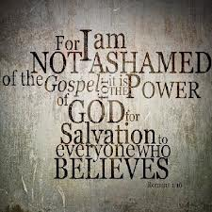
Conclusion:
If you have never put your faith in Jesus Christ, then you should follow the below profound process:
- Recognize your sinful state and the consequences.
- Repent of your sins – asking God to forgive you. Ask Him for power to turn away from sin to follow Him.
- Confess Jesus as your Lord – tell Him and others you are following Him.

Unit 1: Committed to Christ – Lesson 2: Baptism
Questions:
What is believer’s water baptism? Is it important for a follower of Jesus Christ?
Today there are a lot of ideas about water baptism. Some say it is vital, even necessary, for salvation. Others say it is insignificant and just a matter of preference. Some say when and how you do it is important. Others still say it is the meaning that matters.
The truth is that water baptism is one of the most meaningful, important experiences of our Christian life. Every believer should seek to understand and honor Christ through water baptism.
The Example of Christ:
To properly understand the weight given to the practice of water baptism, one need only look to the example of our Savior, Jesus Christ.
- Jesus was water baptized. (Luke 3:21; Mark 1:9-10)
- Jesus commands us to be water baptized. (Matthew 28:19)
Jesus’ example and command make it clear that this is a significant practice to follow and teach.
Biblical Baptism:
Perhaps you have heard people talk about a certain doctrine of baptism. Maybe you have heard people say “well that is just what that denomination church teaches.” Others talk about Orthodox, Catholic or Lutheran teachings of baptism. The truth is there is only one Biblical method of baptism.
The Biblical Method:
There is only one valid water baptism method recorded in the New Testament. That method is by immersion. There is not a single Biblical account of sprinkling or pouring. New Testament baptism was always by immersion.
- Mark 1:9 – Jordan River
- Mark 1:10 – ‘coming up out of the water’
- John 3:23 – ‘there was much water there’
- Acts 8:36 – ‘see here is water…’
- Greek – literal translation is to immerse
Since our desire is to follow the Biblical pattern then we should water baptize by immersion.
The Biblical Meaning:
The Biblical meaning of water baptism and the method used are closely tied together. If you change the method, then you lose the meaning.
- Water baptism identifies believers with repentance from sin. (Matthew 3:11)
- Water baptism identifies believers with Jesus Christ in His the death, burial and resurrection. (1 Corinthians 15:3-4, Romans 6:4-7)
- Water baptism identifies believers with receiving a new nature in Christ. (Romans 6:4)
- Water baptism identifies believers with the Holy Spirit (Acts 2:38)
- Water baptism identifies believers with the body of Christ. (1 Corinthians 12:13)
- Water baptism identifies believers with clothing oneself with Christ (Galatians 3:27)
The Biblical Motive:
There are a lot ideas as to why one should be water baptized.
First, we should establish what the Biblical motivation for baptism is not.
- The act of water baptism doesn’t save us. Receiving grace by faith saves us.
- The act of water baptism doesn’t cleanse sins. The blood of Jesus cleanses sins.
- The act of water baptism doesn’t give one the Holy Spirit. Jesus sends the Holy Spirit.
The motivation for water baptism is…
- To demonstrate love for Jesus. (John 14:15)
- To honor Christ through obedience to His command. (Matthew 28:19)
- To identify self with the death, burial and resurrection of Christ (Romans 6:3-4)
- To identify self with the baptismal work of the Holy Spirit (Mark 1:8)
- To identify self with the local community of Jesus followers. (Acts 18:18)
- To identify self with the new creation (Romans 12:1-2)
- To identify self with those who have clothed themselves with Christ (Galatians 3:27)
- To identify self with the High Priest, Jesus Christ, after the order of Melchizedek (Hebrews 5-7)
Conclusion:
A follower of the High Priest, Jesus Christ, should surely follow Him in water baptism. The method matters. The timing matters. The meaning matters. If you have not been Biblically water baptized – then you should. God will bless it, use it, and will be glorified through it.

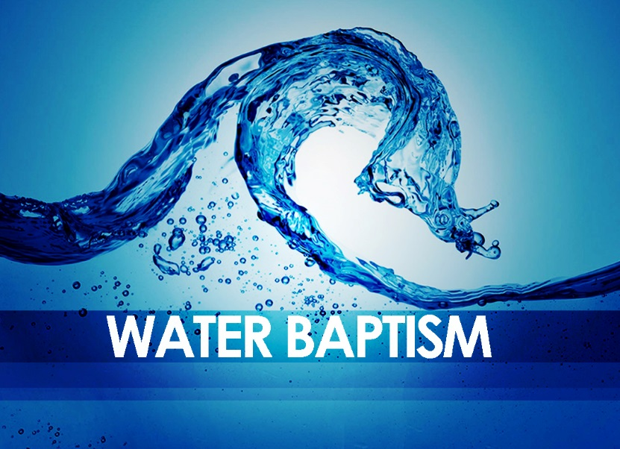

Unit 2: Committed to the Cause of Christ – Lesson 1: The Holy Spirit
Questions:
Who is the Holy Spirit? What is His purpose?
Today there are a lot of differing ideas about the Holy Spirit. Some strange ideas are taught as truth. Some see teaching on the Holy Spirit as confusing or even divisive. For this reason many churches have decided to avoid the subject altogether. This further damages the churches’ understanding of this foundational truth. The truth of the matter is that the Holy Spirit is vital to our lives as followers of Jesus Christ. Rather than neglect or avoid the subject, we should dig deeper into this crucial subject.
Who is the Holy Spirit?
- The Holy Spirit is God. He is one in the Trinity. There is God the Father, Jesus the Son and the Holy Spirit. The Bible presents them as individual persons and one God. (John 14:23-26)
- The Holy Spirit is a person, just as Jesus is a person. We do not refer to the Holy Spirit as an ‘it’. He is an individual and personal.
- The Holy Spirit is the “Helper” or “Comforter” sent to indwell the hearts of all believers after Jesus ascended to His heavenly Father after the resurrection. (Acts 1:3-11)
- The Holy Spirit is God’s gift to those who receive His Son, Jesus Christ, as Lord. (John 15:26)
- The Holy Spirit enables and empowers believers for witnessing about Jesus. (Acts 2:8-9)

When does a believer receive the Holy Spirit?
Scripture is clear that when a person is saved the Holy Spirit seals and indwells the believer. The Holy Spirit is not divisible. It is not possible to receive Him in installments! (Acts 11:17; 1 Corinthians 6:19-20; Galatians 3:2, 14; Ephesians 1:13)
What does the Holy Spirit do in the life of a believer?
The Holy Spirit engages, establishes, equips and empowers believers to live the Christian life aligned with the will of God. We need the Holy Spirit to help us to believe and behave in a manner that pleases God. (Romans 12:2, Galatians 5:22-23)
The Holy Spirit performs these activities in believers:
- Enables believers to overcome the old nature. (Galatians 5:16-17)
- Teaches believers. (John 14:25-26)
- Gives believers godly wisdom. (1 Corinthians 2:12-13)
- Enables believers to proclaim and witness about Jesus. (1 Corinthians 12:3; Acts 1:8)
- Gifts believers to serve the church. (1 Corinthians 12:4-7)
- Empowers believers to overcome Satan and the world. (1 John 4:4)
- Testifies as to the believers’ salvation. (Romans 8:16)
Though there are more activities this list is sufficient for proving the need for the indwelling Holy Spirit.
What evidence is there that a person is filled with the Holy Spirit?
Some people seek to demonstrate that they have the Holy Spirit by producing certain works or signs that verify His presence. Others wonder if they are filled with the Holy Spirit. There is much confusion about being “filled with the Holy Spirit.” But, the Bible is very clear. Evidence of the presence of the Holy Spirit is found in the phrase “fruit of the Holy Spirit.” (Galatians 5:22) There is fruit of love, joy, peace…

Being a Spirit Filled Christian:
The Bible has made it clear – we receive the Holy Spirit completely at our salvation. Yet, the Bible also tells us to be continually filled with the Holy Spirit. (Ephesians 5:18) The question is then – how do we be filled with more of something that we are already full of? Good question!
In Ephesians chapter 5 – God’s Word is talking about being fully under the control of the Holy Spirit who resides within. The process of “being filled” means being “directed.” Just as the person filled with wine is under the control of the wine (in a state of drunkenness) – the person filled with God’s Spirit must stay under the control of the Spirit.
We must be involved in that “filling” process daily. This requires –
- Complete submission. You must submit your will, your plans and priorities to the leadership of the Holy Spirit inside you. He wants to fill your spirit, influence your soul and manifest the will of God through your body, which are His temple. (1 Corinthians 6:19)
- Continual Control. To be filled with the Holy Spirit means you must surrender continual control over to Him. This is not just a one-time desire or event. This is a daily – even moment by moment process. In Ephesians 5:18 the person that is drunk is under the control of another influence. This influence controls their walk, their speech, and even their thought processes. In the same way the influence of the Holy Spirit should control every aspect of our lives. Just like the drunk person must continue to drink to stay in this state, the Christian must continually be filled by continual submission.
What a tremendous blessing God has given us! May we praise Him for the gift of the Holy Spirit who leads, guides, and empowers to fulfill the will of God. (John 14:16-18)

Unit 2: Committed to the Cause of Christ – Lesson 2: Bible Study
Question: What is the Bible and what role does it play in the life of a Christian?
Truth: The Bible is the inspired Word of God. It is perfect, complete, and without error. Our theology is based solely on it. It is our guide in our faith and practice.
3 Facts about the Bible:
- The Bible was inspired by God. (2 Timothy 3:16; 2 Peter 1:20-21)
- The Bible guides us to salvation. (John 20:31)
- The Bible equips us for Christian life. (2 Timothy 3:16-17)
  - Teaching (doctrine) – to teach us how to live
  - Reproof – to show us where we are wrong
  - Correction – to show us what is right
  - Instruction in righteousness – to show us how to live pleasing to God
How to Benefit from God’s Word:
- Hear God’s Word. Be where the Bible is preached. (Romans 10:17; Revelation 2:17)
- Read God’s Word. (Revelation 1:3)
  - Have a plan
  - Make a time
  - Be consistent
- Study God’s Word. (2 Timothy 2:15) Carefully, thoughtfully study God’s Word with:
  - Discipleship groups
  - Bible studies
  - Study Bibles
  - Concordances
  - Bible dictionaries, etc.
- Memorize God’s Word. (Psalm 119:11)
  - Make a plan
  - Be diligent
  - Be consistent
- Meditate on God’s Word. (Joshua 1:8)
  - Consider it
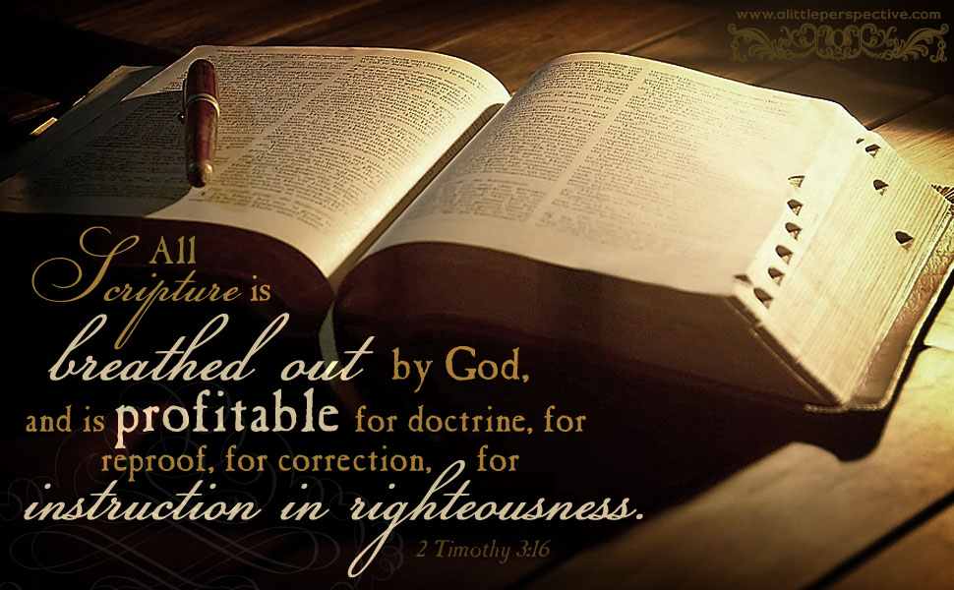
  - Meditate upon it
God has given His people a tremendous blessing through His written Word. Christians should treasure it greatly. It requires our effort to allow it to guide us as we seek to honor God. May we truly be “people of the Book.”

Unit 2: Committed to the Cause of Christ – Lesson 3: Prayer
Questions:
What is prayer? Is it necessary? What does it provide for the believer?
Truth: Prayer is communication with the living God. Prayer is spending time in relationship with God, talking to Him and listening for His answer. It is a blessing and a privilege for God’s people.
What is the purpose of prayer?
Prayer actually has only one purpose. That single purpose is that God’s will would be done. Prayer is the process of seeking God’s will and the wisdom and power to follow it. (Matthew 6:10) Some folks believe, or at least act like the purpose of prayer is to solicit or plead for God to follow our will. Others pray believing they can force God to act. The truth is God’s plan is always best. Prayer helps us determine that plan and then give us the resources to follow it.
What is available through prayer?
Our God is sovereign. He is Creator of all things, Sustainer of all things and over all things! God tells when we pray within His will; He will give us whatever we ask. Therefore, we should realize that available through prayer are all the resources of God. (Matthew 7:7-11, John 14:13-14.)
Who participates in prayer?
Most people claim to at least sometimes pray. Most people believe that any prayer offered by any person is heard by God. In truth, however, prayer involves only two participants – God and His children. Matthew 6:9 says “Our Father in heaven…” Prayer is only between the Father and those designated “His children.” The sad fact is not everyone is a child of God. In the first chapter of the gospel of John we are told who God’s children are. Speaking of Jesus it says “But as many as received Him, to them He gave the right to become children of God, to those who believe in His name.” (John 1:12) Not everybody is a child of God – only believers! The first thing a person must do to have their prayers answered is receive Jesus Christ as their Lord and Savior. God becomes our Father through our new birth.
Why should we pray?
Prayer is a privilege. Prayer is for believers. Yet the question remains – why should Christians be active in prayer? The Bible gives us many different reasons. Some include:
- To receive wisdom. (James 1:5)
- To show God we are thankful. (1 Thessalonians 5:16-18)
- To secure needs. (Matthew 6:11, Hebrews 4:16)
- For strength, boldness, and power to live as a Christian. (Acts 4:31)
How should I pray?
Sometimes we wonder if we are praying correctly. Sometimes we wonder if perhaps there is a better way to pray. Good news! God even tells us how to pray for results!
- With the right motivation. (Matthew 6:5)
- With the right method. (Matthew 6:7)
- With the right model. “The Model Prayer” (Matthew 6:9-13)

Unit 2: Committed to the Cause of Christ - Lesson 4: Sharing Your Faith
Questions:
Should every follower of Christ be involved in spreading the good news of Jesus? Aren’t some people responsible for this endeavor – more than others?
Truth:
Every Christian is called to tell others how they have been forgiven and have found peace with God. It is our privilege and our priority to lead others to Jesus.
A Modern Disconnect:
As we read through the accounts of the early church in the New Testament, we find followers of Christ radically committed to telling others about the hope they have found. We read of men and women who faced great troubles and persecutions to take this stand – yet they persisted. Following Christ and not telling others about Him was not an option.
Today, sadly the opposite seems to be true. We find many people that claim to be Christians and who attend churches – yet rarely, if ever, attempt to point people to Jesus. I’m sure the early church would not comprehend this disconnect between following Christ and following the call of Christ to spread the “Good News.”
God’s Prerogative:
God makes it clear that He loves all people. He desires to be in a close relationship with all people. Unlike man – He is not basing that love on race, education, status, wealth, or a person’s past. He just loves man! That great love causes Him to “save” man through the cost to Him of His Son. No greater expression of love has ever been shown. God’s desire is that man will be saved! He has proven that through Christ. He is not against us – but rather for us! (John 3:16, Romans 5:8, 1 Timothy 2:3-4, 2 Peter 3:9)
God’s Plan:
The Bible is clear that God loves man. In fact He has gone to great lengths to save man. Through Christ His work is done. Salvation is available to all people by repenting of their sins and placing their faith in Jesus. Here is a great mystery – however! God’s plan is for His people to tell others – so they too might receive this salvation. In reality He has entrusted this movement to us! The truth is that God has called His followers to be so passionate about Him that they take up His cause. His plan is to get the word out through His people. You might say “What is God’s plan ‘B’.” – There is no plan ‘B’. People will find Christ through the faithfulness of God’s people or they will forever perish never knowing God’s great love because of the failure of God’s people. (Matthew 28:18-20, Acts 1:8, 1 Peter 3:15)
Our Priority:
Understanding God’s prerogative, seeing God’s plan, and hearing Christ’s call – sharing our faith, is to become a believer’s priority. Some people believe that someone else is better equipped, or more gifted at telling others about Jesus. Others still think we have hired church staff and evangelists to take care of this. Yet, the Biblical truth is that all Christians are to take up this effort. Not doing so is disobedience and being out of the will of God.
The good news is that God will enable us for His important work. He will give us the power and even the words to say. We simply have to be faithful and to make the effort. (2 Corinthians 5:20)

Biblically Sharing Your Faith:
So far, three things are clear. First, God desires that not one person should perish; second, God’s plan is for His people to lead others to Him; third, it should be our priority to lead others to Jesus. However, the sad fact is that most Christians, as many as 90 percent, have never led anyone to Christ. What can we do about this situation?
The Witness of Three Testimonies:
People will get saved based upon three testimonies. Understanding these three will help Christians witness to others with boldness and courage.
The Testimony of the Holy Spirit:
The first thing to understand is that salvation is God’s work. It is He who draws men unto Himself. (John 6:44, John 12:32) We should realize that salvation is God’s work and our responsibility is to be faithful to spread the hope we have within us. If we are committed to do our part we can be sure that He is doing His part. Right now the Holy Spirit of God is working in the lives of countless people, convicting them of their sin and pointing them to Jesus. Relax. This is God’s work.
The Testimony of Christians:
People will be willing to hear the good news of Jesus based upon your testimony! You have experiences others can relate to. You can reach people others cannot. Your testimony is a powerful tool! However, the truth is your testimony is only powerful when you share it.
Satan has fooled many people into believing they do not have a testimony or that no one wants to hear their testimony. This lie has kept many people on the sidelines far too long. Actually, if you are a follower of Christ YOU have a testimony for Christ.
Three major parts of your testimony:
- What you were before Christ.
- How you were introduced to Christ.
- What your life is now “in Christ.”
Christians should think about these three things. They should plan how they will tell others. (Even rehearse your testimony.) This simple story – your story – will carry great impact with others looking for hope. People by nature love stories. They especially love ones with great endings. Be prepared to tell others your story. God WILL use it!
The Testimony of Scripture:
Many people, if asked, will say they are Christians or that they are saved. However, of these same people, the majority cannot tell you Biblically what that means. Be sure that Scripture tells us exactly what it means to be saved. We must then know how to use God’s Word to lead someone to Christ.
Many scriptures can be used to point people to the truth of the gospel. We probably will not be familiar with them all. Therefore, we would do best to have a plan to use specific verses. Some examples are:
- John 3:16
- Romans 5:8
- Romans 3:23, 6:23, 10:9, 10:13
- Other plans – Gospel Tracts, etc.
We should familiarize ourselves with the method that we plan to use. Practice makes sharing the gospel of salvation seem more natural. Practice also helps ease our fears of making mistakes. Remember, the key to witnessing is that God does the work. We simply remain active and faithful.
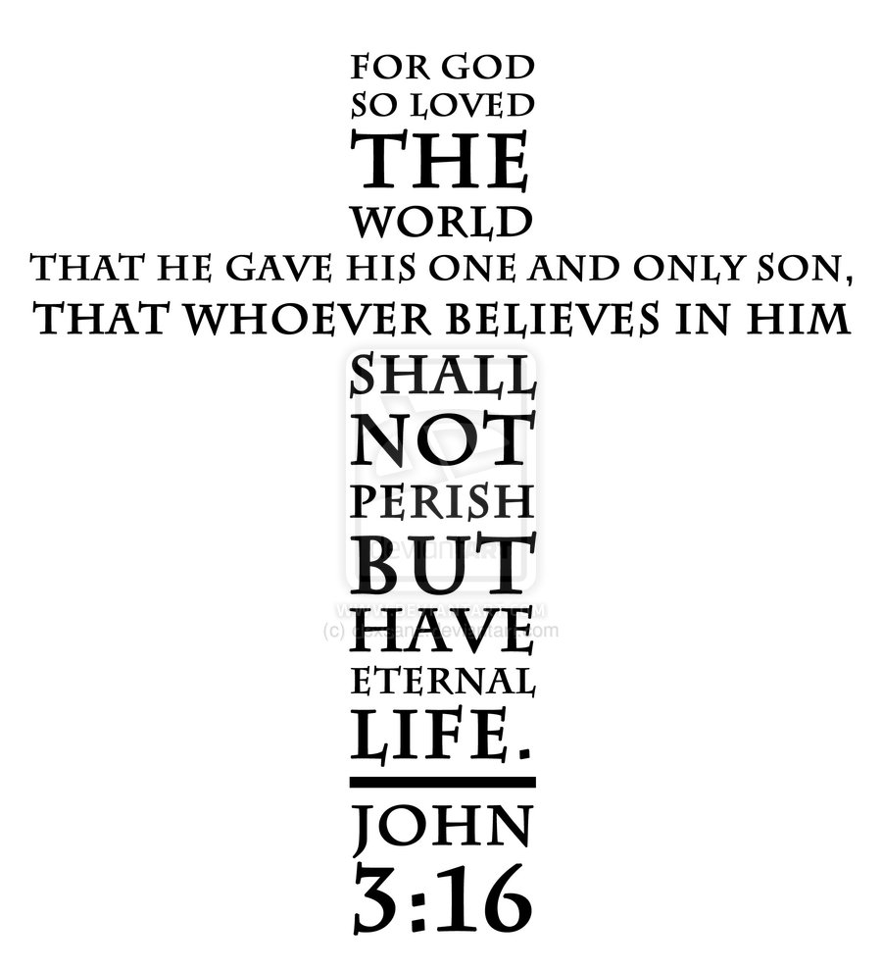

Unit 3: Committed to the Body of Christ – Lesson 1: Participation in Church
Question:
Is it important for a follower of Jesus Christ to be actively involved in a local church?
Truth:
It is absolutely vital for Jesus’ followers to be committed to a local church. It is God’s plan to develop us, to encourage us, and to use us for His service. Outside of this relationship with a local church our Christian walk is hindered greatly.
The Body of Christ:
The Bible refers to the church as “The Body of Christ.” (1 Corinthians 12:12, 14, 27) This analogy tells us much about a properly functioning church. First and foremost Jesus himself is the “Head” of the body. (Colossians 1:18, Ephesians 5:23) This means that much like a physical head – Jesus is the leadership of the body. Just like activity of a physical body is dependent on the head, every activity in the church should be directed by its head – Jesus Christ. Just as a physical body is dead separated from its head, the church not focused on and led by Jesus is also dead.
The analogy of the church as “Christ’s Body” also gives us an indication of the church’s purpose. The body (church) carries out the activities as directed by the Head (Jesus). Simply put, we in the church are doing what Christ would do on earth. We, as His body, are about His work. We literally are the hands and feet of Christ on the earth! This means that the church is not concerned with what it wants to do, or what others would want it to do – but rather the activities as directed by Christ.
The picture of the church as a body also tells us clearly about the importance of each member. Just as a physical body missing various parts is handicapped, so is the church body hindered when its pieces go missing. It would be ludicrous to expect a physical body to operate without limbs or vital organs! At the same time the church is sometimes expected to operate without all of its members (1 Corinthians 12:14-22)
The Gift of the Church:
Perhaps people see the local church as a place, or a sort of club, or a religious organization instead of seeing it really as it is – a gift from God. Salvation by faith in Christ is an individual decision. After that decision, however, God places us in community. It is His creation. It is His plan. (1 Corinthians 12:18)
This community has the same leader (Jesus), the same purpose, the same focus and will encounter many of the same situations. God places us in the community to be trained, taught, encouraged, prayed for, and to find a place to serve! (1 Corinthians 12:26-27) To be a Christian and to try and operate outside of this community would be terrible. The church was created for us. We have been placed in it. We need the church – and the church needs us!
Our Duty to the Church:
As we begin to see God’s design for the church and as we see His plan for it – it becomes increasingly clear that we have a responsibility to the church. It is more than a place to go or a club to belong to, it is a responsibility to uphold. The cause of Christ needs your commitment. The community of Christ needs your participation. As a person committed to Christ you must also be committed to His body – the church.

So, isn’t the church still – voluntary?
Yeah – yeah – the church is God’s plan and the church is God’s design. It is His gift to His people. But, isn’t the church still voluntary? What if you do not like the church? What if you do not like the preacher? What if you have visitors to your house? What if you are watching the sports game on television? What if you are busy? What if…? Isn’t the church still just an option?
The apostle Paul makes it clear that we are needed and that we all have responsibilities in the church. In fact, the church suffers when we do not participate. In the book of Acts we see how the early church members needed one another. We see how God’s purpose is carried out by this community. Read Hebrews 10:23-25. The Bible is clear – the church will bless us! Also, however, we are commanded to participate in the life of the church. If all the positive reasons are not enough – it is a Biblical command. To not obey that command is a sin.

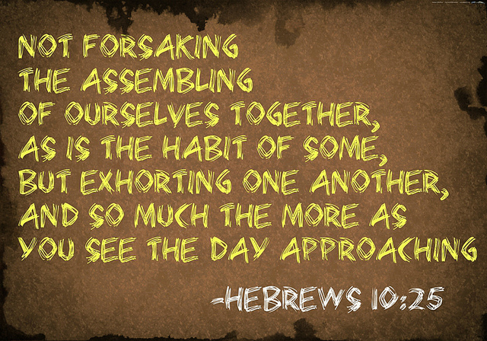

Unit 3: Committed to the Body of Christ – Lesson 2: Unity
Questions:
How important is it for a church to be unified? What does that really mean? What can happen if a church is not unified?
Truth:
It is absolutely vital for the local church to be unified. Anything less than total unity and cooperation detracts from the work of Christ through His church.
The Disaster of Disunity:
Have you ever heard of a church in the middle of a “church fight”? Have you ever been a part of a church caught in such a conflict? Truthfully – did anything good come out of it? The truth is that conflict in the church is a disaster. Satan uses conflict to destroy and derail the mission of a church, if even only temporarily.
Disunity is a Disgrace to the Church:
Disunity is a disgrace to the local church. To think of a place that teaches grace, mercy, and forgiveness caught in a conflict really destroys any validity the church hoped to have. The church instead of being different – is exactly the same as the world around.
Disunity is a Disgrace to Christ:
Jesus, the “Head” of the church, stands for peace. In fact, Jesus is called the “Prince of Peace.” Jesus said that He came to bring peace to a world marked by the absence of peace. It is easy to see that when His followers are caught in ugly conflict, it not only reflects poorly on the church – but also on Jesus.
Disunity is a Distraction to God’s Mission:
God has a mission for His church. This mission has been entrusted to His church alone. When the church gets pulled into conflict, then this mission is delayed and possibly even destroyed. Satan must laugh when he sees the possibilities and the power of the church – all distracted by fighting and disunity.
The Cause of Disunity:
While the reasons for church conflict can be countless, the root cause is always the same – sin. While people may smile at the issues that churches fight over it is a truly a serious matter. Wherever a church can be found in conflict we can be sure Satan is at work. Selfishness, pride, gossip, and malice all lie at the center of church conflicts. It is not funny or a small matter. This is the display of sin.
Jesus and Church Unity:
Jesus knew the schemes of Satan as well as human nature. He knew the destruction that could result from disunity. The seriousness of this issue drove Jesus to pray for believer’s unity. Jesus prayed this prayer when he was close to Calvary and close to His own death on the cross. Unity was that important to our Savior. (John 17:11, 20-23.)

How Can the Church Protect Unity?
- Pray – Just as Jesus prayed for our unity we should pray that we are unified and that God protects our unity.
- Be Offensive - Christians should go on the offensive when it comes to protecting the unity of the church. That means that we do everything in our power to resolve issues, speak well of others and encourage church unity. (Romans 12:18)
- Be Defensive – Christians should at the same time defend the unity of the church. Christians should defend the leadership, the staff, the programs, the members as being part of the same team. Negative talk should be replaced with positive talk that promotes the good of the church.
- Serve – I have noticed that people who are serving faithfully in the cause of Christ are less likely to disrupt that cause. Those who are serving faithfully are seldom at the core of church conflicts.

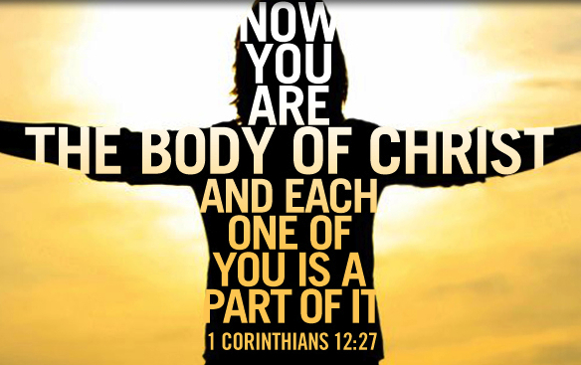

Unit 3: Committed to the Body of Christ – Lesson 3: Giving
Question:
Should Christians commit to giving to their local church? Is giving optional? Does giving influence a believer’s walk with Christ?
Truth – Every Christian should be a consistent, committed and cheerful giver, not for the sake of the church alone, but most importantly for the believer’s Christian walk.
Why does the Bible Emphasize Money and Possessions – If you read through the Bible you will discover the reoccurring theme of money and possessions. In fact, in the New Testament there are more verses on money than either heaven or hell. Did you ever wonder why? Does God need your money? Is this emphasis on money a ploy to transfer people’s wealth to churches or pastors? The truth is that our spiritual condition is clearly reflected by our attitudes and actions toward money. In fact, no other issue may clearly point to our choice between God’s system and the world’s system than how we use our money.
Read Luke 12:16-34
Think about how we view money. Think about how central money is to all we do. Think about what money says about the following:
- Where is our hope?
- Where is our security?
- Where is our faith?
- What brings us joy?
- What do we long for?
- What is our priority?
- Are we generous?
Money clearly indicates our true belief system. Isn’t it interesting that God knows this? How profound that God would then instruct us in how to view and use money and wealth.
Read Matthew 19:16-26
The Tithe – The starting point of God’s instruction on giving begins with the tithe. Tithe literally means the tenth part of the whole. Many people consider the tithe as the maximum demanded amount of giving. However, the Bible defines the tithe as the minimum level of giving. The Bible describes other kinds of giving above and beyond the ten percent. (Leviticus 27:30, 32; Malachi 3:8-10)
God uses the tithe and His instruction on giving to train His people. In their culture, just like ours, people were trained to acquire, attain and to hold onto wealth. Wealth was a measure of success and provided some measure of comfort. In this area God decided His people would be different. Instead of greedily holding wealth, God’s people would give it.
This giving would then show:
- Their obedience
- Their trust
- Their priority
- Their very hearts – where your heart is there is your treasure…

Three Truths about the Tithe:
- The Tithe is God’s – We sometimes act like we are being generous and we will give our tithe to God. As we look at the language in these verses we see the opposite is true. The tithe belongs to God. In fact, Malachi 3 says to not give the tithe is to steal from God!
- In fact, everything is God’s – the truth is everything belongs to God anyway. God has allowed us to use money and possessions as His stewards. If you doubt that then think about who held your wealth 200 years ago. Who will possess your wealth 200 years from now? It clearly was not you and will not be you! (Psalm 24:1; Deuteronomy 10:14; Leviticus 25:23; 1 Chronicles 29:11-12; Psalm 50:10-12; Haggai 2:8)
- God Blesses by Giving to People – As God’s people become faithful in giving – God teaches us and trains us – but, God also promises to bless us! (Malachi 3:10; Luke 6:38)
Regarding the discipline of giving, God is not trying to burden or to punish us. Rather, God’s goal is that we learn to trust Him. God blesses us so that we can be a blessing to others!

Unit 3: Committed to the Body of Christ – Lesson 4: Serving with Spiritual Gifts
Question – What is a spiritual gift? What is its purpose? Does everyone have a spiritual gift? What are your spiritual gifts?
Truth – A spiritual gift is a supernatural enablement, given to Christians by God to enable them to serve and to build up the church. Every Christian has at least one spiritual gift and is responsible to be a steward of that gift.
How are You Using Your Spiritual Gift?
- Some believers simply do not know what Biblical spiritual gifts exist. They have no idea about their particular spiritual gifts.
- Some are withholding their gifts. For whatever reason they are not actively using their gifts to benefit the work of God through His church.
- Some are misusing their gifts. Some are using their spiritual gift in negative ways for personal benefit or using their spiritual gift elsewhere.
All three of these situations hurt the church. When all of the membership do not show up and actively use their gift, the church becomes handicapped. The ministry of the church becomes limited. Simply speaking, this hurts the church.
What Spiritual Gifts are not?
To better understand our spiritual gifts, it is helpful to see what a spiritual gift is not. There are false ideas about spiritual gifts. First, a spiritual gift is not a sign that a person has more or less of the Holy Spirit. A spiritual gift is independent from being “filled with the Holy Spirit”. A spiritual gift is also independent from the “fruit of the Spirit” as listed in Galatians 5:22. Fruit is what results from a Spirit filled person.
Spiritual Gifts:
Below are three lists or categories of spiritual gifts and brief descriptions. You may discover that your spiritual gifts are a matrix of particular gifts from each category. Your particular gift set is unique. You should neither feel inferior or superior from your specific gift set. These spiritual gifts were not given for your benefit. These spiritual gifts were not given for comparison. Instead, they were give for the purpose of cooperation, witnessing and equipping Christians for the work of ministry building up the church.
Seven Motivational Gifts from the Father for Redemption (Romans 12:6-8):
Prophecy: (Romans 12:6) – the ability to have insight from God and to discern motives and roots of problems and to design solutions.
Servant: (Romans 12:7) – the ability to practice loving action seeing and meeting immediate needs without any desire to build a personal empire.
Teacher: (Romans 12:7) – the ability to validate and emphasize the accuracy and facts of truth in a systematic way.
Exhorter: (Romans 12:8) – the ability to stimulate and inspire and easily move people relationally towards love faith and works.
Giver: (Romans 12:8) – the ability to strategically undergird or support valid worthwhile and successful ministries.
Leader: (Romans 12:8) – the ability to develop strategies, gather resources and motivate a team towards reaching both short and long term goals.
Mercy: (Romans 12:8) – the ability to sense and comfort those who are in distress with compassion.
Nine Spiritual Gifts from the Holy Spirit for Edification (1 Corinthians 12:8-10):
Word of Wisdom: (1 Corinthians 12:8) – the ability to apply supernatural knowledge to life in such a way as to make spiritual truths relevant and practical in decision-making and daily life situations.
Word of Knowledge: (1 Corinthians 12:8) – the ability to supernaturally know things that you could not know other than by divine intuition or revelation.
Faith: (1 Corinthians 12:9) – the ability to supernaturally inspire the church towards actively claiming and pursuing the promises of God by faith.
Gifts of Healing: (1 Corinthians 12:9, 28, 30) – the ability to supernaturally heal the spirit, soul and body setting them free from illness and disability.
Effecting of Miracles: (1 Corinthians 12:10, 28) – the ability to supernaturally perform powerful actions from the spiritual to the physical realms.
Prophecy: (1 Corinthians 12:10) – the ability to supernaturally proclaim the Word of God boldly leading hearers to respond to the message of the Word that they have heard.
Discernment of Spirits: (1 Corinthians 12:10) – the ability to supernaturally distinguish spiritual truth from error judging whether the action or message is from God, Satan, or humans.
Tongues / Interpretation of Tongues: (1 Corinthians 12:10) – the ability to speak and interpret in a language not previously learned. When the message is interpreted God’s message is heard and God is glorified.
Five Church Leadership Gifts from the Son for Equipping (Ephesians 4:11-12)
Apostles: (Ephesians 4:11) – Christ sets these people in office for the purpose of launching new initiatives blazing a trail into new territories.
Prophets: (Ephesians 4:11) – Christ sets these people in office for the purpose of boldly making known the Word and will of God to a public audience.
Evangelists: (Ephesians 4:11) – Christ sets these people in office for the purpose of clearly explaining the gospel message to unbelievers so that they believe and come into the church.
Pastors: (Ephesians 4:11) – Christ sets these people in office to shepherd a flock of believers with gentle care, feeding, guidance, correction and training in righteousness.
Teachers: (Ephesians 4:11) – Christ sets these people in office to carefully instruct others in the Bible in a clear, logical and concise way leading to unified understanding and spiritual growth in the body.
How Can You Determine Your Spiritual Gift Set?
There are some practical ways you can determine your spiritual gift. Your spiritual gift should not be a mystery! God does not want spiritual gifts to be like a mysterious puzzle. After all, God intends for us to both know and to use our spiritual gifts for His glory and for the growth of the church. How practically can we determine our gifts?
- Consider God. Pray for God to reveal your spiritual gift.
- Consider your past. What have you been successful at? Where do you have an ability?
- Consider the surrounding needs. Many times the needs that stand out to you will point to the area of your giftedness. Your observations could indicate your giftedness.
- Consider experimenting. Try several different ministries to see which ones you enjoy and are successful at.
- Consider Christ’s commands. Read what the Bible says and obey Christ’s commands.
How Can You Be Certain of Your Spiritual Gift?
- Enjoyment. It must bring you much joy and satisfaction
- Encouragement. Others will see the gift working in you and will encourage usage of the gift.
- Enablement. God will enable you to accomplish the task.
- Enlightenment. God will enlighten you through using the gift.
Now Go to Work!
Once a follower of Jesus finds their spiritual gift they are to be a steward of that gift. This means that they are responsible to put the gift to use, for God’s glory, in their local church. To do otherwise hurts the ministry of the church. Simply put – we must go to work.

